# IN712 JavaScript Canvas Practical

1. Write a JavaScript function that draws two rectangles that intersect like the figure shows. Note that one of the rectangles needs to have alpha transparency.

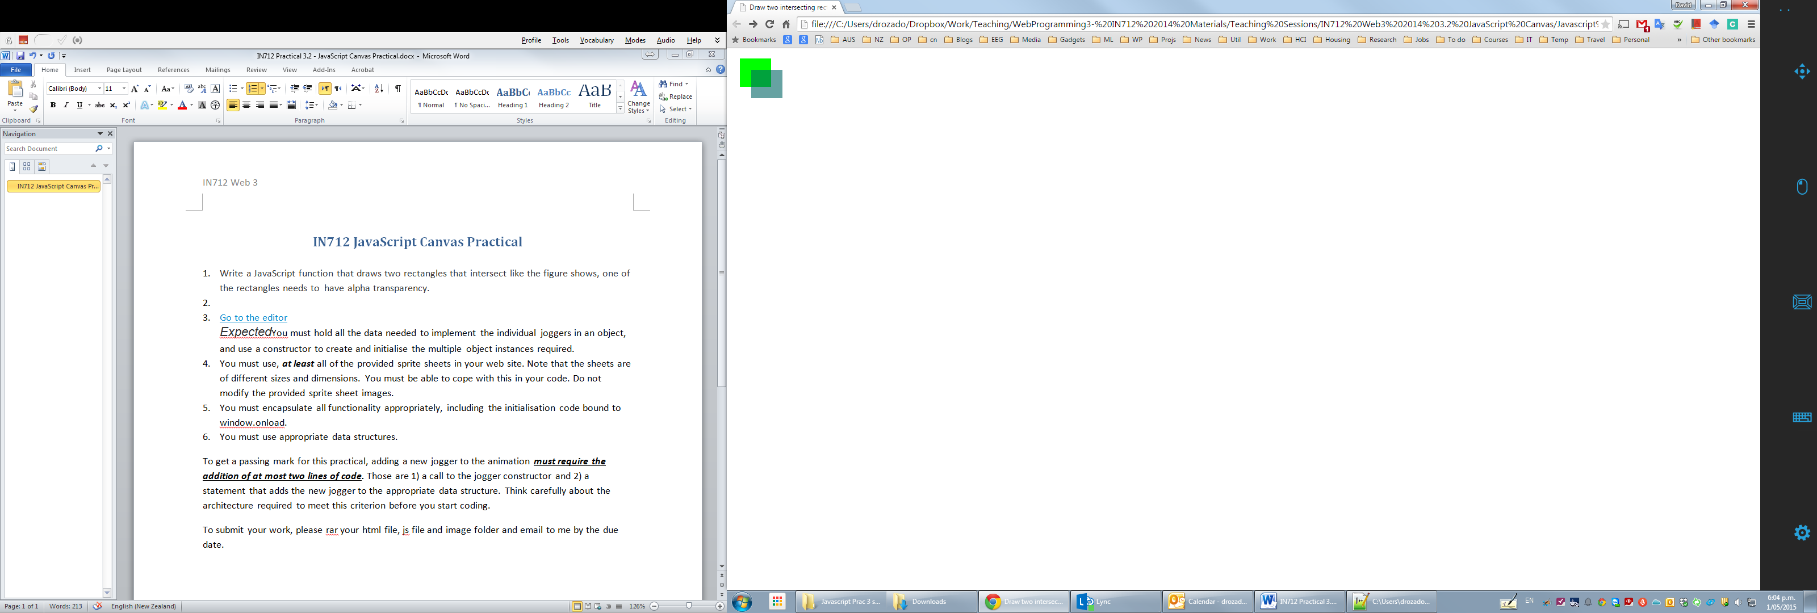

1. Write a script that displays the current date and time (using the javascript Date object) in the provided HTML (inside the div element with id of output). Make it update every second. Hint: use the javascript setInterval function.
2. Write a JavaScript function that draws the following shape using a canvas path. Make it appear 5 seconds after the page loads.

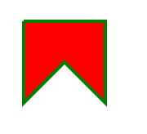

1. Write a JavaScript function that animates a black box to move from left to right:
2. Write a JavaScript function that draws a smiley face like the figure shows.

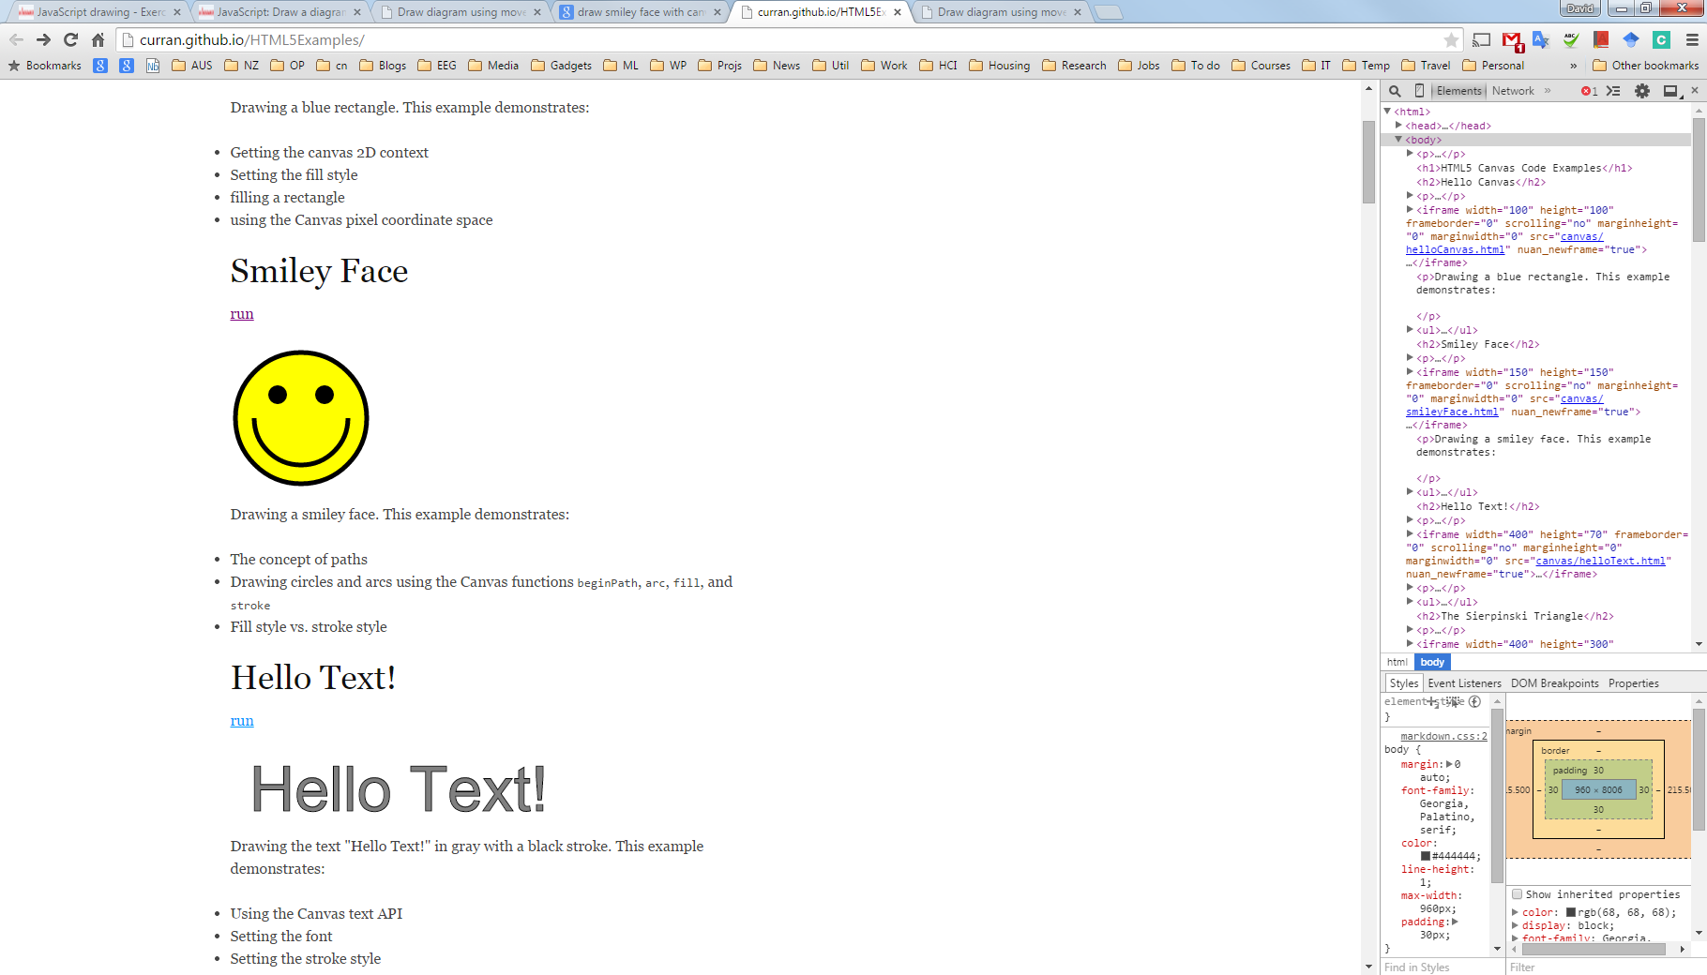

1. Create an animation of the earth circling around the sun

